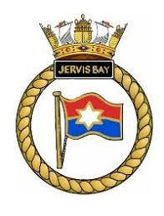
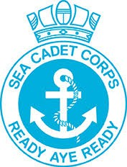
Reading Sea Cadets Open Day
Self-Discipline

If you enjoy activites that include:

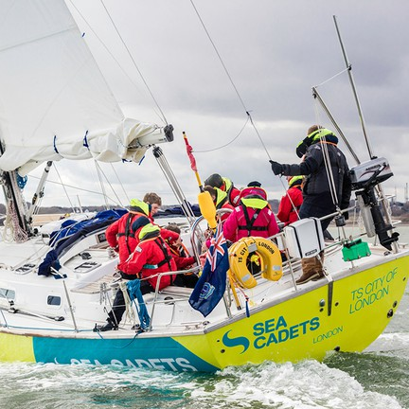
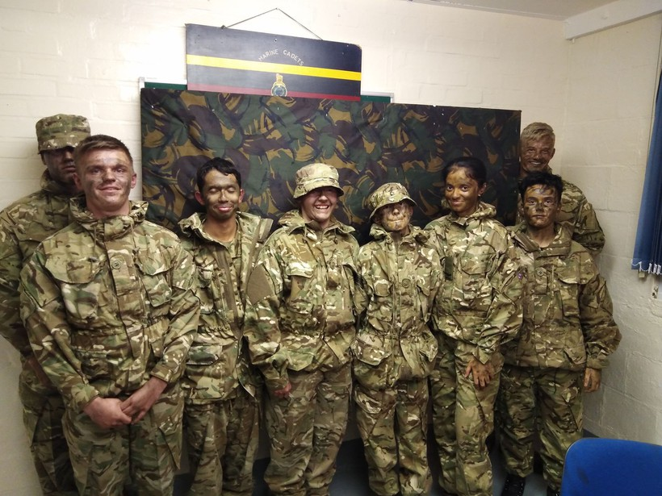
Adventure Training Music
First Aid
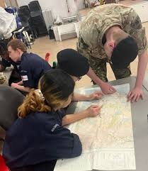
Shooting Seamanship Rowing Sailing
And so much more
Book A Place at our OPEN DAY When: 13th April
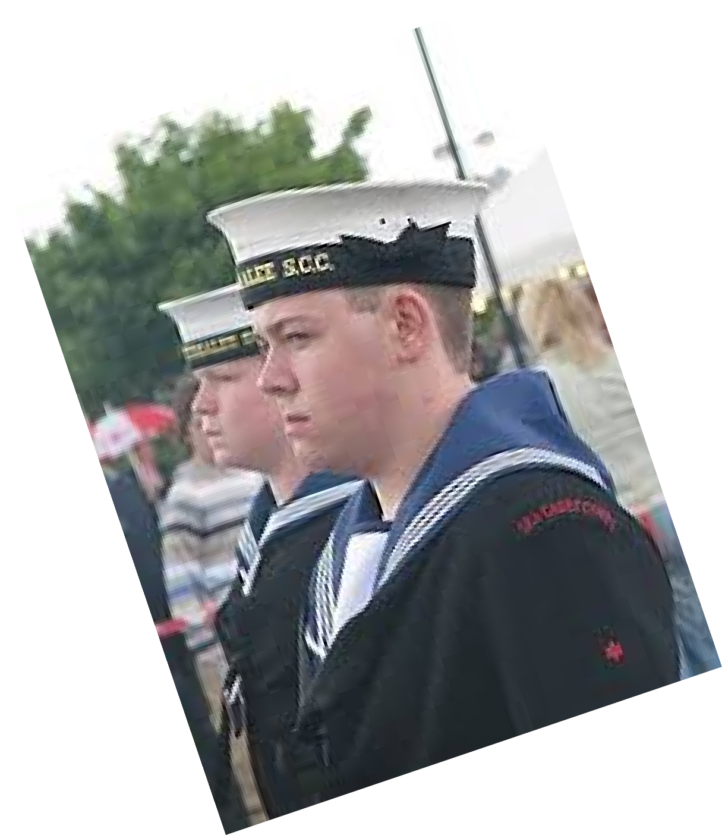
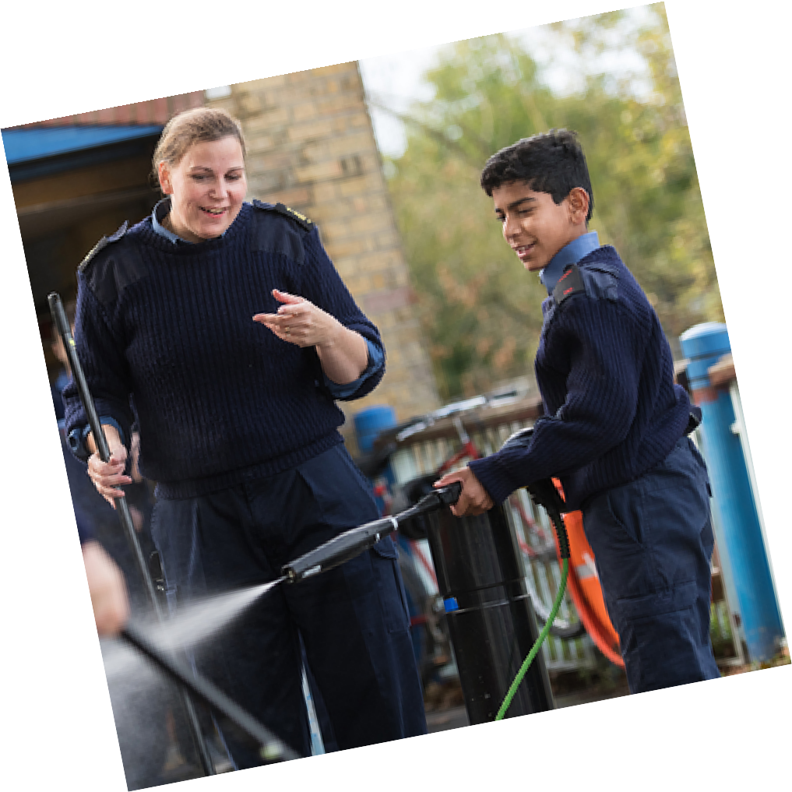
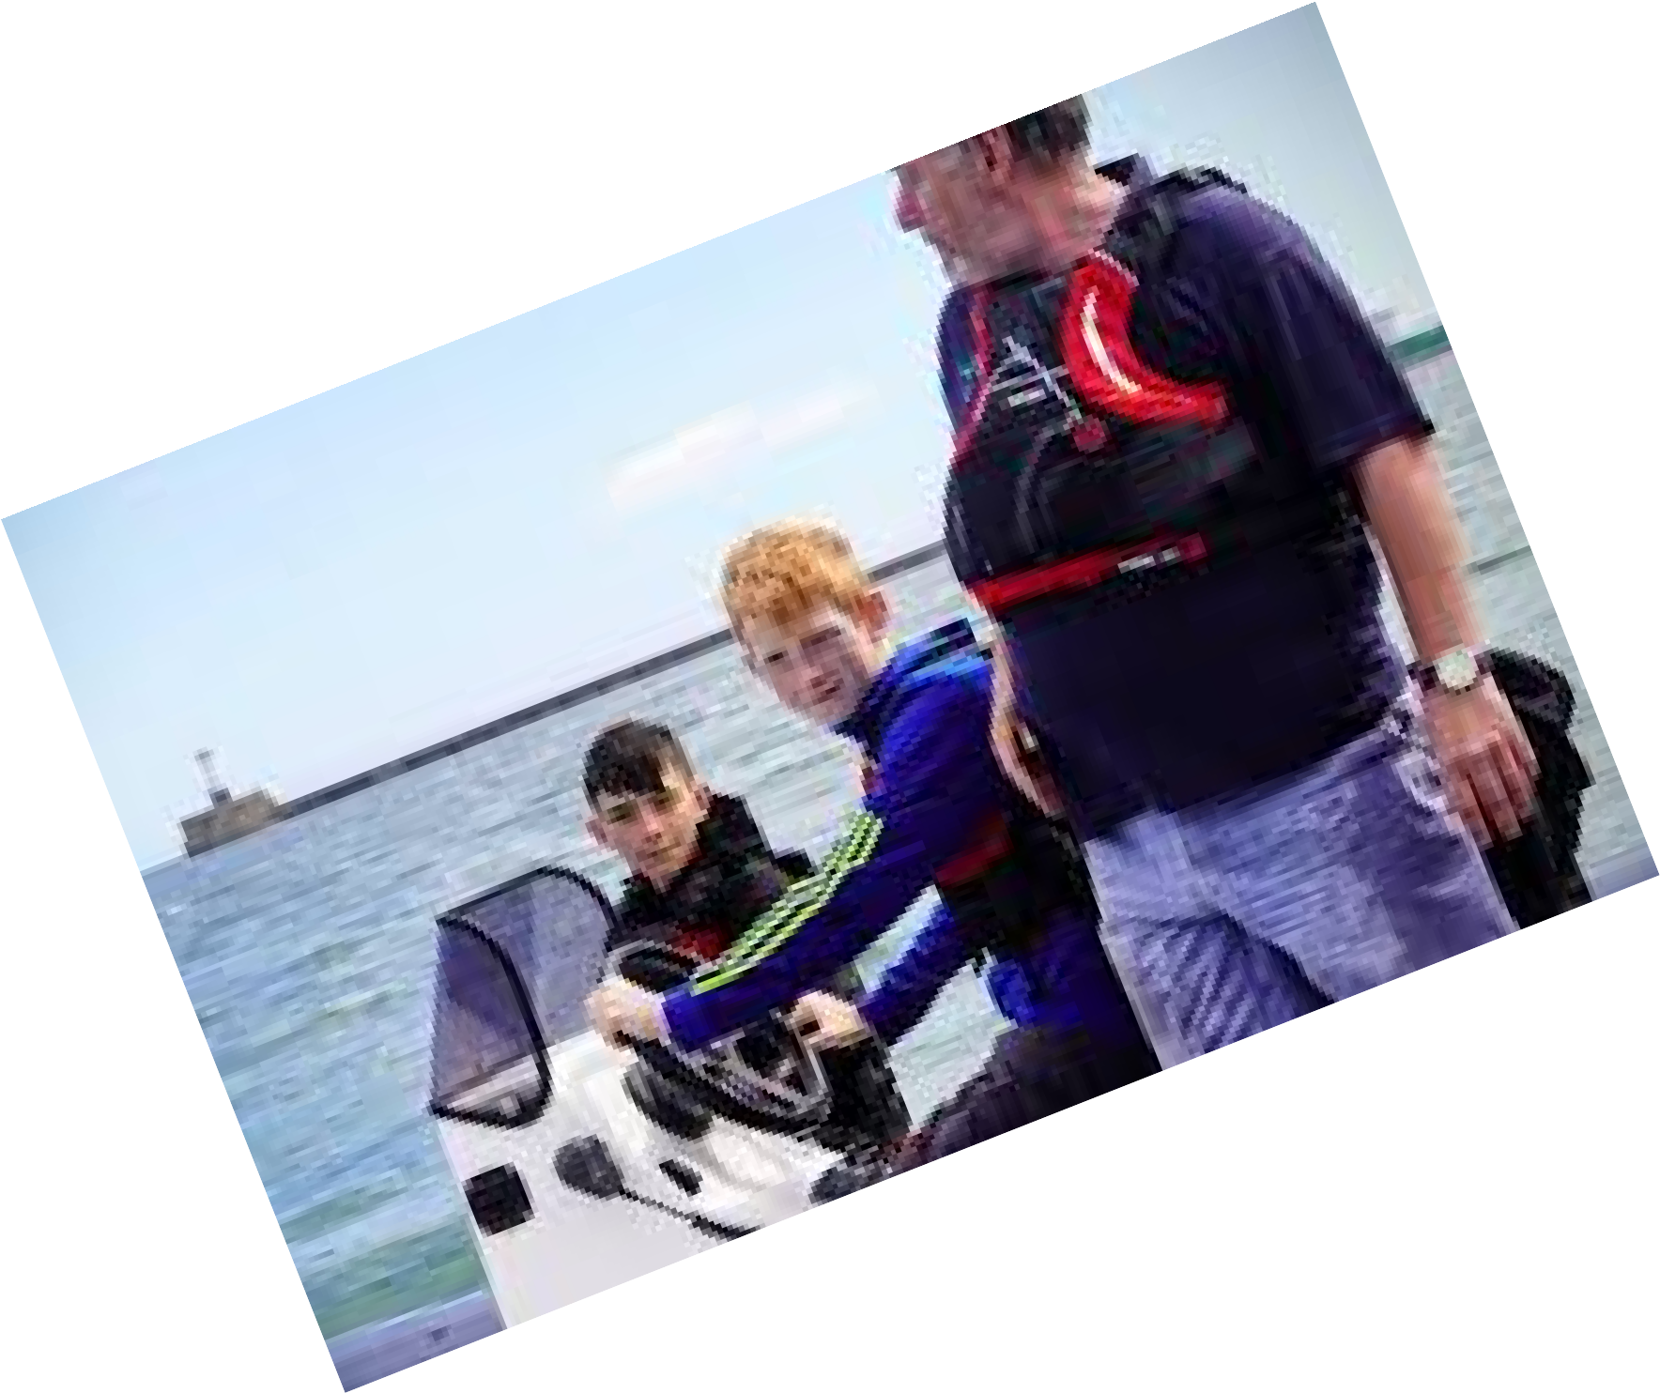

Where: Brock Barracks, Oxford Rd, Reading RG30 1HW
Courage
Adaptability
Leadership

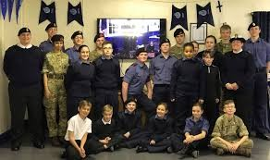
Book your Place Now AT:
Email: info@280readingseacadets.co.uk Phone: 07903704094

